Car prices are shown as ints, not doubles/floats because I’ve never seen a real car priced out with cents.

Same as the rent variable in Chapter 3 Lab 2! 😊

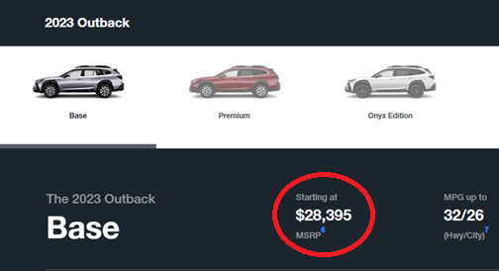

‘Twas a fun class!